

American International University-Bangladesh (AIUB)

**Department of Computer Science**

**Faculty of Science &Technology (FST)**

**Spring 2020-2021**

**CSC 2210 Object Oriented Analysis and Design (OOAD)**

**Section: F  
Group No: 02**

**PROJECT TITLE: RAILWAY E-TICKETING SYSTEM**

An Object-Oriented Analysis and Design (OOAD) project submitted

By

|  |  |  |  |
| --- | --- | --- | --- |
| SL No | Student Name | Student ID | Contribution |
| 01 | MONOWARA PARVIN | 19-39578-1 | 20% |
| 02 | MAISHA TAHIAT | 19-39581-1 | 20% |
| 03 | TASNUBA KADER RAISHA | 19-39616-1 | 20% |
| 04 | RATUL HASAN RAHAT | 19-40647-1 | 20% |
| 05 | NAFINUR LEO | 20-42195-1 | 20% |

# CHAPTER 1: PROBLEM DOMAIN

## Project Background Analysis

* **Write the background description that helps putting the project into the right context of a problem domain and gives everyone involved a common view of the project.**
* Railway E-ticketing system is a way for travelers to reserve their desire seats through online without the hassle of being present physically. It will help the travelers to gather information about particular train timing and then they can easily reserve their desire seats. This project is about the analysis of railway e-ticketing system. We tried to represent the flow of the system clearly by five diagrams.
* **What is the root cause of this problem? why is this problem is so important to consider?**
* Bangladesh is a populated country with many problems. The population of Bangladesh is speared throughout its districts. So, people have to travel other districts for their respective work or job. It is very time consuming to stand up in a line and waiting for buying tickets. Sometimes it takes many hours to buy train tickets and sometimes we also don’t get ticket by standing in lines for hours. It wastes our valuable time. E-ticketing is the best option for reserving seats easily. The use of the internet makes buying a ticket more convenient since the service is available at any geographical location, including your home and at any time of the day, any day of the year. So, the problem is important to be considered.

## Project Solution and Feasibility Analysis

* What are the solutions you are going to propose to deal with the problem? why is this   
  solution is particularly appropriate to solve the problem? Is the solution feasible to the   
   meet the business objective?
* To deal with the problem we are going to propose some solutions which is given below:

i) The project objective will be focused on developing an online e-ticketing system to ensure the effectiveness of buying ticket. Moreover, the system will offer a complete management system that integrated with the online e-ticketing system to help the travelers for getting their tickets in short time.

ii) The registration can be done online without the need of paperwork anymore. It is also helping the travelers to get more information about his destination.

iii) The system will get easier way to determine the seat of the tickets and keep track of the registration module.

This solution is particularly appropriate to solve the problem because travelers and clerks can do this registration process without facing any paperwork issue and it can be done easily because of technology.

Yes, the solution is feasible to meet the business objective. Because in this system travelers will have to be connected through the network and here the network provider will also get the business benefit.

* Provide a short description of the software being specified and its purpose, including relevant benefits, objectives, and goals?
* Here, the software which is being specified is railway e-ticketing system. In this project we’ve shown that how an online ticket reservation system works and its process step by step through Use Case diagram, Class diagram, Sequence diagram, State chart diagram and Activity diagram.

Now the purpose, including relevant benefits, objectives and goals is given below:

**Purpose:** The purpose of this project is to develop an object-oriented model for railway e-ticketing system.

**Benefits:** The benefits of this project are the system will offer a complete management system that integrated with ticket reservation to help the travelers for getting their tickets in short time.

i) The system provides an online interface to the user where they can fill in their personal details and submit the necessary documents.

ii) The system concerned with the issue of tickets. Clerks can use this system to reduce their workload and process the application in a short time.

iii) Provide a communication platform between the travelers, clerks and system.

**Objectives:** The main objective of creating the document about the software is to know about the list of the requirement in the software project part of the project to be developed. It specifies the requirement to develop a processing software part that completes the set of requirements. The cores of objectives of the project are followings:

i) To propose an online ticket reservation and management system.

Ii) To identify the user requirement for online ticket reservation and management system.

**Goals:** Online ticket reservation system is an interface between the travelers, clerks and railway system. It is responsible for the issue of tickets. It aims at improving the efficiency in the issue of tickets and reduces the complexities involved in it to the maximum possible extent.

* Existing studies presented in the problem area. What are the existing software solutions are available to solve the aforementioned problem?
* There are many existing software solutions are available to solve this problems. If we look into other developed countries, we can see that they use one online platform where travelers, clerks and railway system are connected. As Japan Railway uses online ticket reservation system where travelers can booked and buy his tickets using online platform. So, we can say that there is some existing software for this kind of problem.
* What makes this project new, innovative, interesting, or otherwise distinct from other similar projects? Does the project duplicate functionality already available in the market?
* This Railway E-Ticketing System is a modern and innovative project. You can book your tickets without any troubles and doing the whole process in an online platform with your smart devices like phone or laptop. It is kind of a blessing for the travelers. The whole entire system has so user-friendly attitude and the proposed system is very efficient. Now travelers can know any kind of details regarding the seats instantly. Then don't need to go outside and have to wait for long time standing in a line. Traveler can select destination, ticket detail, confirm reservation, cancel reservation, easy to pay, search availability of tickets. The railway system also takes a lot of benefits like creating form, modifying form, returning money etc. The whole process of the system is quite easy and time consuming. You just need an internet connection. We have fast server, because of that our server never be slow down. This system monitoring all the process automatically. May be this kind of project is available in the market but we can ensure that we have got the best solution for the problem.

Finally, we can say this project is totally new, innovative, interesting and distinct from other similar projects in the market.

# CHAPTER 2: UML DIAGRAM

## 2.1 Use Case Diagram

* + **Does the use case narrative represent the Scenario of the use case diagram?**
* Yes, here the use case narrative represents the Scenario of the use case diagram.
  + **Does the Use Case diagram include the major use cases, actors who perform the use cases and the relationships among the use cases needed to deliver by the system?**
* Yes, the Use Case diagram includes the major use cases, actors who perform the use cases and the relationships among the use cases needed to deliver by the system. Here we’ve three actors in our project: Travelers, Clerk and Railway System. The relationship among the use cases is clearly shown by the features.
  + **Case study:** Railway e-ticketing system is software developed to computerize the process of possessing a travel ticket. In railway e-ticketing system, the primary actors are travelers and clerk and the secondary actor is railway system. Travelers, clerk and railway system login to their accounts. Travelers can select destination, search availability of tickets, view ticket details, view ticket category, book ticket, fill form, pay amount, confirm reservation and request for tickets from their account. Clerks can also view ticket details, confirm reservation, cancel reservation and return money. Railway system can make ticket available for both travelers and clerks. Here, it is mandatory to set ticket details before ticket available. Railway system can create form, modify form, return money, assign clerks etc. Moreover, railway system can confirm reservation by response to request.

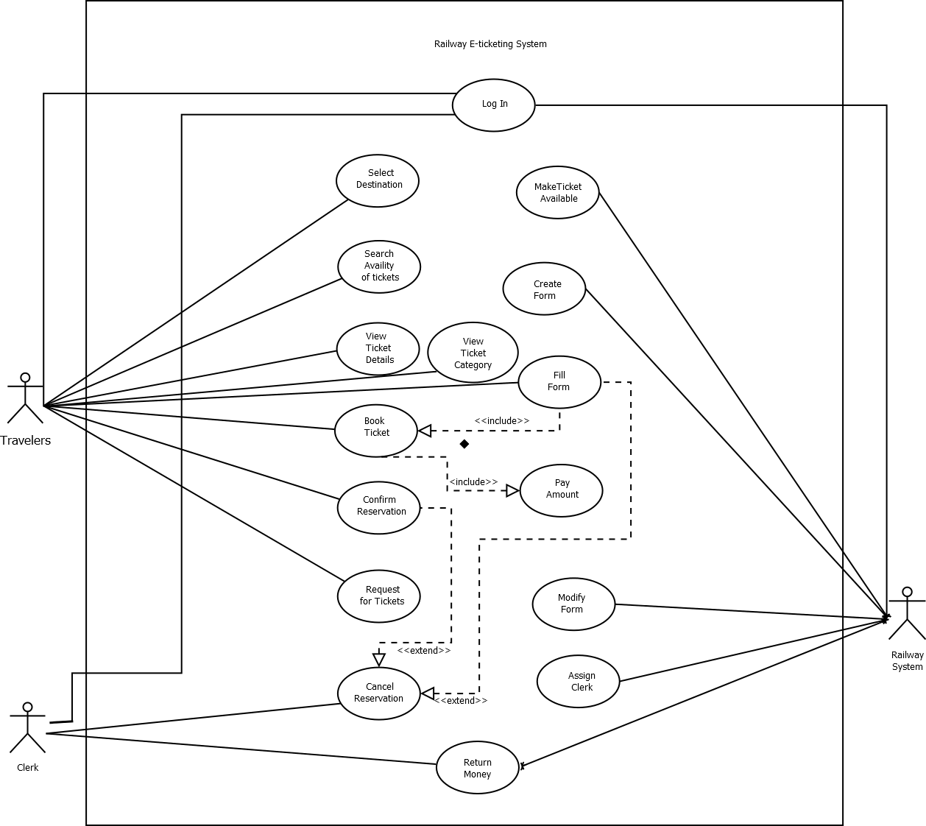

## 2.2 Class Diagram

* + **Does the class narrative represent the Scenario of the class diagram?**
* Yes, the class narrative represents the Scenario of the class diagram.
* **Does the Class diagram include the major classes (attributes, operations) and the relationship among the classes needed to deliver by the system?**
* Yes, the class diagram includes six major classes like Travelers, Clerk, Railway System, Train, Payment and Ticket. Here the class diagram includes the relation among the classes needed to deliver by the system.
* **Case study:** Travelers can buy any number of tickets. Travelers can login, select destination, search availability of tickets, view ticket details, view ticket category, book ticket, fill form, pay amount, confirm reservation and request for tickets from their account. Every ticket has no, status, person number etc. Clerk can confirm reservation, cancel reservation, and return money. Train has name and no. Railway system can make tickets available and assign clerks.

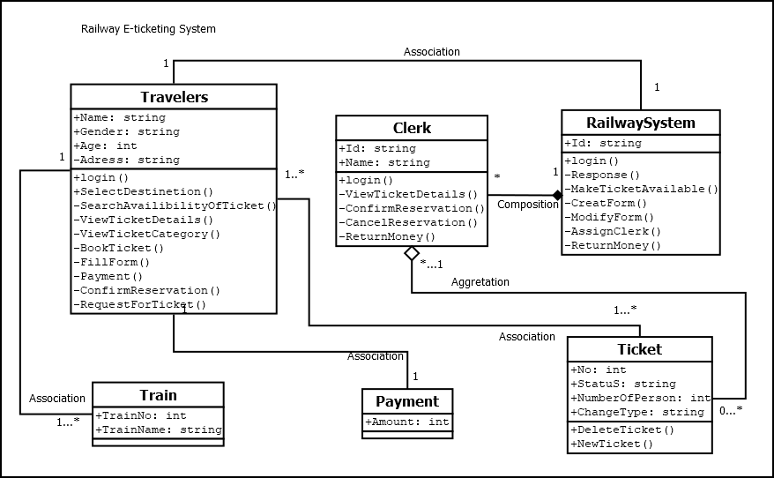

## 2.3 Sequence Diagram

* **Does the sequence narrative represent the Scenario of the sequence diagram?**
* Yes, the sequence narrative represents the Scenario of the sequence diagram.
* **Does the Sequence diagram include the sequence of the major activities needed to deliver by the system?**
* Yes, the sequence diagram includes the sequence of the major activities needed to deliver by the system.
* **Case study:** A traveler requires booking a ticket through internet. Travelers will login and request to reserve a ticket to the railway system. Railway system receives the request and then the request passed it to clerk. Clerk checks the current booking database to find out the availability of seat, seat number and facilities. Facilities are sending to the system through clerk. Travelers can show available seats and then confirm their desires seat. Then railway system passed the requested seat to the clerk .Clerk confirmed the seat through database. Eventually a copy of the ticket is sent to the system and a copy is given the travelers.

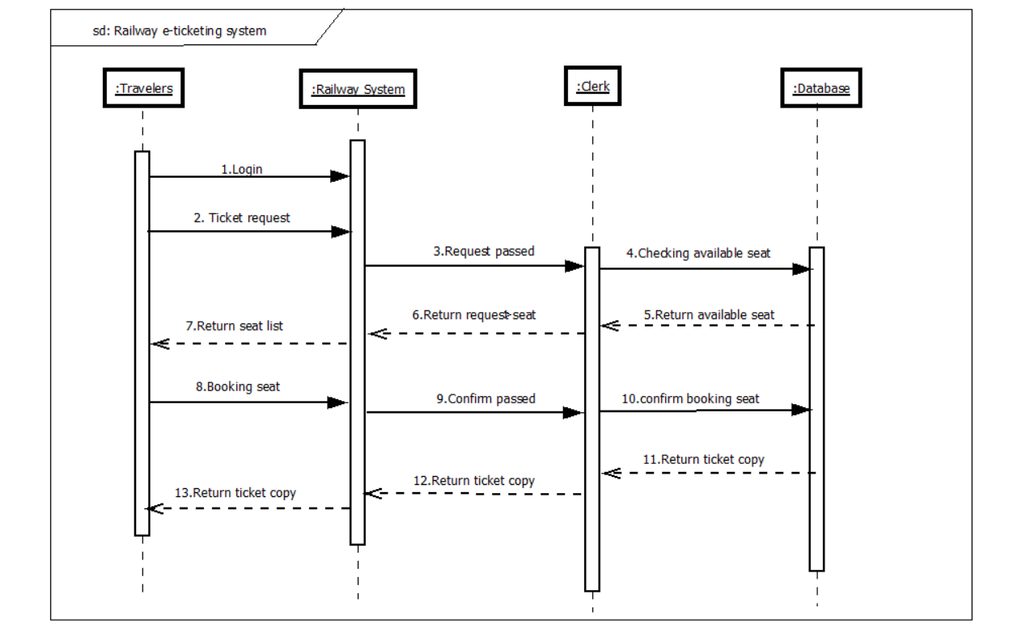

## 2.4 State chart Diagram

* + **Does the state chart narrative represent the Scenario of the state chart diagram?**
* Yes, the State chart narrative represents the scenario of the state chart diagram.
* **Does the State chart diagram include the major states needed to deliver by the system?**
* Yes, the State chart diagram includes the major states needed to deliver by the system.
* **Case study:** The travelers will login to the railway system. If the login fails, the travelers will go back to the homepage. If the login succeeds, the travelers will enter the page containing ticket details. Then the travelers will fill up a form and then will choose the seat and get the specification of the ticket. The traveler will confirm the reservation. If the payment method is invalid, the travelers will go back to the homepage. If the payment method succeeds then the travelers will get the ticket and end up process.

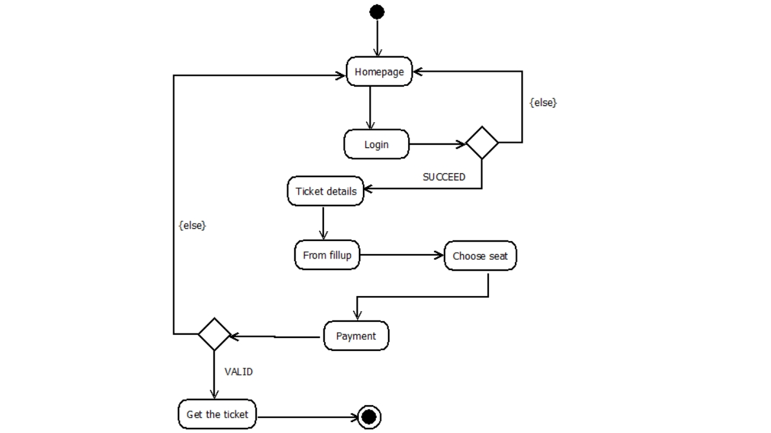

## 2.5 Activity Diagram

* + **Does the activity narrative represent the Scenario of the activity diagram?**
* Yes, the activity narrative represents the scenario of the activity diagram.
* **Does the Activity diagram include the major activities needed to deliver by the system?**
* Yes, The Activity diagram includes the major activities needed to deliver by the system.
* **Case study:** First system creates available seats for both clerk and travelers. The system shows the ticket details to the clerk and travelers. After viewing the ticket details, travelers choose the seats and fill up the forms. System assigns the clerk to accept the reservation request. If the seats are available, clerk confirm the reservation request. If the seats are not available, clerk request to the system to assign another available seat. Then system views the request and assigns available seats to travelers. After that travelers can confirm their reservation.

